**Finding Lane Lines on the Road**

**Writeup Template**

**You can use this file as a template for your writeup if you want to submit it as a markdown file. But feel free to use some other method and submit a pdf if you prefer.**

**Finding Lane Lines on the Road**

The goals / steps of this project are the following:

* Make a pipeline that finds lane lines on the road
* Reflect on your work in a written report

**Reflection**

**1. Describe your pipeline. As part of the description, explain how you modified the draw_lines() function.**

My pipeline consisted of 5 steps. First, I converted the images to grayscale, then I applied a gaussian blue function on the grayscale with kernel size of 5. After that, I detect the edges with canny function. Photo as following:

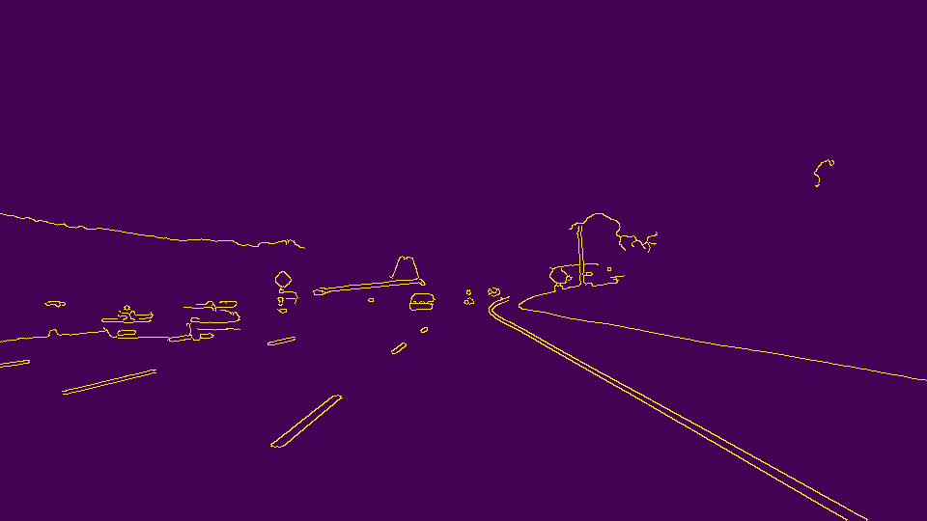

Then, I created vertices to define the front polygon region as interest. Based on that, I used the Hough transform function to detect the line segments and applied draw line function to draw them on a blank image. Lastly, I combined original image and the line image.

In order to draw a single line on the left and right lanes, I modified the draw_lines() function by separating line segments based on their slope. For each category I calculated their mean point coordinates and average slope. Then I extrapolate the line by finding the top and bottom coordinates while the line passed that mean point with the average slope.

**2. Identify potential shortcomings with your current pipeline**

One potential shortcoming would be what would happen when there is a jungle sitting next to the edge of the lane, my algorithm could comprehend it as lane line sometimes.

Another shortcoming could be same as the jungle, the back bumper of a moving car especially a white car can disturb the outcome by treated as the lane line edge.

**3. Suggest possible improvements to your pipeline**

A possible improvement would be to adjust the Hough transform parameter by decrease the max gap and narrow down the qualified line segments. Also shrink the region of interest.

Another potential improvement could be to add a mask to highlight the white and yellow color before convert the image as gray. In this way, the raw data will be more result oriented. So the outcome of the pipeline could be more accurate.